

**TELEX**

TXo & TXi

QUICK START GUIDE

Revision .017 • 20171114

©2017 bpcmusic

**Welcome**

Congrats on purchasing or building your TELEX module(s). This endeavor has been a massive learning experience and a serious labor of love to put together for us. Your support has been sincerely appreciated all along the way of this journey!

This quick guide is an attempt to consolidate some important details for you and get you up and running in no time with your TELEX. While you may not be a “read the manual” type of person, you will very likely save yourself a lot of time and frustration by giving this a quick glance. But, who are we kidding, if you aren’t a read the manual type of person then you aren’t even reading this and we’re just wasting everyone’s time. We all blame you for this.

If you run into any problems along the way, feel free to reach out for assistance. The best place to do this is on the monome forum “lines” at:

http://llllllll.co/t/a-teletype-expander

Getting Started: Firmware

Required Teletype Firmware

Your Telex module(s) require firmware later than version 2.0 to be installed on your Teletype. Head on over to the monome repository and update that firmware if you want the Teletype to be able to speak with your TELEX. Instructions for the Teletype update process are also on the monome site.

https://github.com/monome/teletype/releases

TELEX Firmware Upgrades

Your TELEX shipped with the latest firmware available at the time of its construction. If some time has passed, there is a good chance that a new version may be available. You can always check at the GitHub TELEX microsite:

https://github.com/bpcmusic/telex/releases

To upgrade your firmware, you will need to connect the Teensy processor on the back of your TELEX to your computer. It is critical to turn the power off on your TELEX or (better) simply remove the Teensy from the back of the module during this operation. Follow the procedure for loading firmware onto the Teensy that is appropriate for your operating system using the Teensy Loader. Links and details are on the release page above.

DO NOT connect your module’s Teensy processor to USB while it is connected to Eurorack power. This will cause bad things to happen. Chernobyl-style bad things. Resist the temptation – it will only lead to wanton destruction.

If you wish to roll up your sleeves and debug the module via USB, you will need to separate VIN from VUSB on the underside of the Teensy. This is a simple procedure that should be done carefully to ensure that you don’t damage your Teensy, module, computer, or fabric of the universe.

Getting Started: Connections

Connecting Your TELEX to Eurorack Power

The TELEX modules follow the “red stripe down” paradigm of power connections. This means that the -12 side of your Eurorack cable should be at the bottom of the module. This is marked on the silkscreen as “< -12” alongside the vertical Eurorack power connector.

While the TELEX was designed with reverse power protection, this hasn’t been fully tested out of concern for the safety of rare prototypes, Teletype modules, power supplies, and small animals. It is highly recommended that you ensure that your power connections are oriented properly and fully connected. (If you do screw this up, let us all know what happens. In the meantime, we’ll be looking for the swirling vortex in the sky.)

After connecting things to your TELEX, ensure that the 3 layers of the module are properly seated. The two boards and Teensy should be flat and snug. You will damage your unit if it is not properly put together when powered up. That would suck.

Connecting the TELEX to Your Teletype via II

The II bus consists of two signals (SCL and SDA) and a ground wire. Your Teletype shipped with a cable affixed with 2x3 connectors and a six-conductor ribbon cable. This works fine – but can be a bit of a pain in the rear to wrangle when you have a bunch of modules connected to the bus.

We have included a three-conductor jumper wire with your module to facilitate their connection to the II bus. You can use either method – but there are important considerations you need to keep in mind:

* On the Teletype and Trilogy Modules, the II pins are oriented top to bottom (ground on the top).
* On the TELEX modules and Ansible, these pins are oriented bottom to top (ground on the bottom).
* On the TELEX modules, two vertical columns of II pins are present and slightly separated (2x3 connectors won’t cover both columns – they are designed for jumpers).

Ensure that you are appropriately orienting your ground wire when connecting the devices together. The rule is “Twist to the Teletype or Trilogy” - if you need a mnemonic.

The diagrams below illustrate where the pins are located on the two modules.

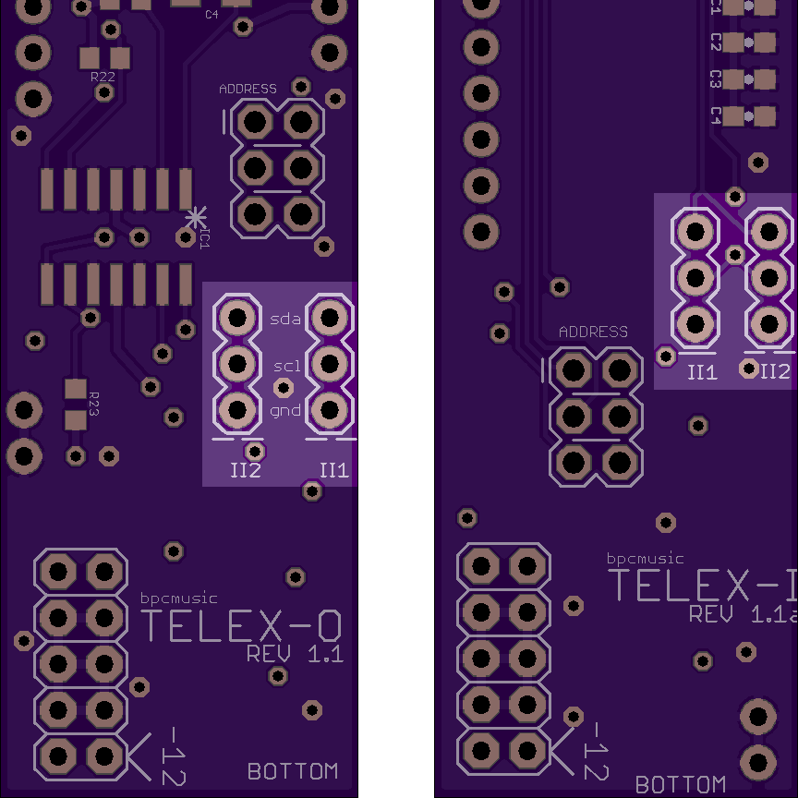

Fig. 1: TELEX II Connectors

The white lines below the columns on the PCB designate the locations of the ground wire.

Connecting Four or More II Devices

When connecting a larger number of devices to your Teletype, you will need to supply additional “pull-up” to the bus to have reliable communications. These handy bus boards (designed by Brian at monome) do the trick and are easy to build.

The iiBackpack mounts on the back side of your Teletype and provides twelve 2x3 II connection points. It is awesome.



Fig. 2: iiBackpack - https://oshpark.com/shared_projects/eVzh387f

The iiBusboard sits externally and provides eight 2x3 II connection points (one is taken up by the connection to your Teletype). Take care to ensure that the bottom of your iiBusboard isn’t shorting to anything metal in your case.



Fig. 3: iiBusboard - https://oshpark.com/shared_projects/FrAGyqU3

Connecting Multiple TELEX

A single II bus can support up to eight of each TELEX module type. You set a jumper on the back of the TELEX to differentiate the modules on your system after adding your first one of each type.

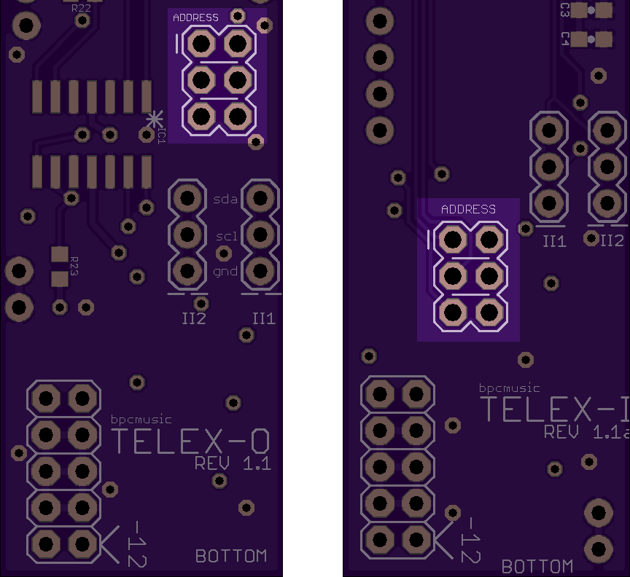

Fig. 4: Jumper Locations on TELEX

The number is coded in binary on the set of three jumpers on the back of your TELEX. The X in the chart below indicates where to install the included jumper if you want to rest your brain.

|  |  |  |  |  |
| --- | --- | --- | --- | --- |
| **Row 1** | **Row 2** | **Row 3** | **Unit #** | **Inputs/Outputs** |
| - | - | - | 1 | 1-4 |
| X | - | - | 2 | 5-8 |
| - | X | - | 3 | 9-12 |
| X | X | - | 4 | 13-16 |
| - | - | X | 5 | 17-20 |
| X | - | X | 6 | 21-24 |
| - | X | X | 7 | 25-28 |
| X | X | X | 8 | 28-32 |

The jumper is located within the little plastic bag of screws and stuff that you’ve lost since opening your module’s box. Check in the sofa cushions or in that place where your cat drags things. If you can’t find it, it is time to get creative.

Using Your TELEX

The Basics

This documentation assumes you understand the operation of your Teletype. (Go hit the Teletype’s documentation and tutorials first if you are new to the platform. They’re pretty fun and inspiring.) The good news is that once you have the hang of the Teletype, you only have to learn a few more things in order to extend this knowledge to the expanders. Here’s the big one:

For basic operations, the TELEX modules implement the same operators as the Teletype – with a little twist. Teletype commands that output signals are sent to a TXo using the “TO.” prefix and Teletype commands that read values are read from a TXi’s inputs using the “TI.” prefix.

With that, you automatically know all of the TELEX basic commands. (Talk about efficient documentation! We’re patting ourselves on the back right now.) Anyway, to use them, just refer to the appropriate output number. Your expanders start numbering their outputs at 1, just like the Teletype.

We’ve included a one-page command reference (which is an excerpt of the full Teletype documentation). You can find the complete, current documentation that includes all of the extended TELEX commands on the monome site:

https://monome.org/docs/modular/teletype/

We **HIGHLY** recommend that you familiarize yourself with the documentation for the TELEX. With great power comes … screw it. Just RTFM and ENJOY!!! ;) ;) ;)

Addressing Multiple Expanders

You also may have noticed that you can add up to eight of each expander to your Teletype. Yes, this is nuts. We’ve done it. It scared the animals. Thing is, we really wanted you to be covered in case of an emergency. Here is how you can do it yourself.

Inputs and outputs added to your system by the TELEX expanders are addressed sequentially: 1-4 are on your first module of any type, 5-8 are on the second, 9-12 on the third, and so on. It’s pretty easy – just takes a little counting to target the input or output of your choice.

In order for multiple expanders of the same type to be used with your Teletype, you have to set the jumpers properly on the backs of your expanders. Please refer to the previous section “Connecting Multiple TELEX” for more information on how to do this safely and confidently.

Glerk. There is one more point to call out here. Apologies for the double indented blue-things. We know it is lazy. In fact, we’re only continuing to write text here in order to space them out a bit more and make it seem intentional. It’s working, right? We almost look like we know what we are doing. :)

A few of the commands in the documentation reference the module by its unit number – but those are rare and are generally pretty obvious as they operate on the module as a whole as opposed to a single input or output.

Extended Capabilities

Ok. This is where the TELEX start to diverge a bit from the Teletype. You see, we had some horsepower to spare with our powerful little Teensy processor. We figured it would be immoral not to put those extra cycles to some use. So, once we implemented the Teletype’s command set, we kept going. :)

Here are some key things that you can explore; check the full documentation for the details:

* Unlike the Teletype, the CV outputs on the TXo are bipolar. They support voltages from -10V to + 10V. If you have modules that like to be driven by negative voltages – you are in luck!
* The IN jacks on the TXi are also bipolar. Drive them with negative voltages and you will get negative values when you poll them. Pretty handy – when you need it.
* Most time related commands support longer durations than the Teletype’s maximum millisecond threshold. By using the “.S” and “.M” operators, you can specify and extend pulses and slews by seconds or minutes. (Want a slew that lasts 22 days, 18 hours, 6 minutes, and 59.9904 seconds? We’ve totally got you covered!)
* CV outputs and inputs have operators that you can use to set values that are quantized to a user-selectable scale (changed using the “.SCALE” operator). This can be done using note numbers directly (“.N”) or by quantizing a voltage to its nearest value using the “.QT” operator.
* Inputs can have their ranges mapped to return the values you desire using their “.MAP” operator. They also can be calibrated using the “.CALIB” operator, but this can be tricky. Please refer to the full documentation for help on this procedure.

Experimental Functionality

This is where it gets nuts. Unfortunately, this is also where you might get a little confused. Let’s assume that you haven’t already frustrated yourself trying to get some of the crazier functionality working and retreated to the manual as a last ditch effort before throwing your whole modular rig out the window.

There is one super-important thing you need to understand:

For envelopes and oscillators to work, you need to set the voltage for the target CV output to be a non-zero value. They use this value for their peaks and, without it, they will look broken. It’s like trying to play music with your speakers turned all the way down to zero. Music might be playing somewhere – but you aren’t going to hear it unless you turn up the volume.

Ok. With that out of the way, here is a short inventory of what you can do. Again, please refer to the latest Teletype documentation for full descriptions and examples.

* Each trigger output has its own independent metronome, addressed using the “TO.TR.M” operator. This metronome pulses its output at the specified rate when it is active.
* Metronomes can also be set to pulse a certain number of times an automatically stop using the “TO.TR.M.COUNT” operator. You can do some pretty neat things with this if you are clever.
* All four of a device’s trigger metronomes can be addressed as one using the “TO.M” set of commands. Note: these commands use the DEVICE NUMBER as opposed to any particular output.
* Each TR output also has an integrated pulse divider that causes it to skip pulses that are sent to it (“TO.TR.P.DIV”). Whether driven by its own internal metronome, setting the DIV value to anything but 1 will cause pulses to be skipped.
* Each CV output has an oscillator paired with it that can do crazy stuff (morphing waveforms, rectification, LFO-rates, microtonality, etc.) – as long as you remember to turn up the output’s voltage. You can access the oscillation functionality using the collection of operators under the “TO.OSC” tree.
* Each CV output has an envelope that can control its amplitude over time (using the “TO.ENV” tree of operators). This one can be tricky because, when you turn it on, it will turn you CV down to the current zero value until it is triggered via the “TO.ENV.TRIG” operator. This can be confusing. Sorry.
* The CV voltage, envelopes, and oscillators all interact to do cool stuff. Try exploring what negative voltages do to envelopes and LFO-rate oscillators. Check out how envelopes and oscillators work together. Have fun with the “OFF” and “CTR” values. Play with “PHASE”, “SYNC”, and “SLEW” to do some wild things.

Oscillator Expectation Management

The TXo wasn’t designed to be a full, four-voice oscillator module in 4HP. As it stands, it’s sampling rate only supports pitches up to about 8kHz. Also, it has filters on the outputs that were designed for control voltages. This means that even sine waves get pretty aliased as you go up in frequency without additional post-filtering. As the module itself doesn’t oversample, the other waveforms it supports include (at no extra charge) some amazing aliasing for you to enjoy and leverage in your compositions. Have fun with it – we do!

In Conclusion

Thanks for your interest in the TELEX and your support in this endeavor. We had a blast making this for you. If you have any trouble or questions, please don’t hesitate to reach out. For best results, do it on the forum in the TELEX thread.

Before we’re done here, we should call out how crazy indebted we are to the community for helping to make it happen. We learned so much through this process. The TELEX wouldn’t be in your hands today without all of the people that stepped up to provide ideas, contribute advice, review hardware designs, politely correct our ignorant mistakes, contribute firmware code, give suggestions on how to do such a complex build, ensure that the Teletype’s i2c capabilities were ready for our release, and provide the awesome ecosystem in the first place.

Rather than list everyone here and miss folks – you can watch all of it unfold in real-time up in the TELEX thread on lines. It was and is an amazing thing to be a part of. If you are as appreciative as we are, please share it with the crew up there!